* Hygiene check
* Data Modeling
* API Integration
* Server-Side Logic
* User Interface Design
* Team Management
* Data Handling
* Communication
* Analytical skill

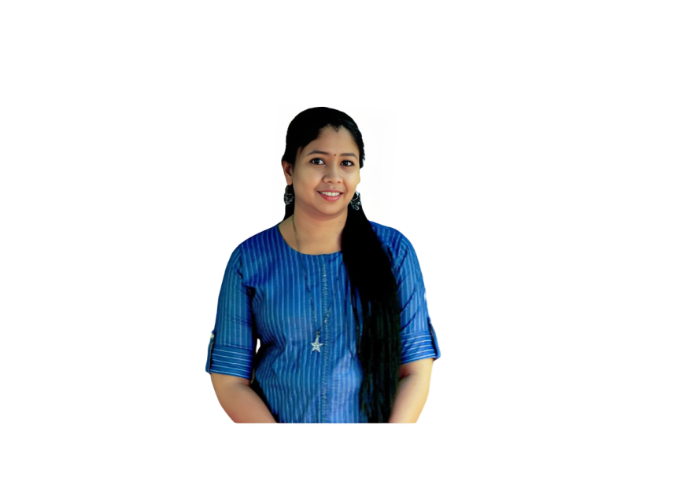

* Full Stack Development
* Django Framework
* Web Applications
* HTML5

**KEY SKILLS**

**SRUTHI SURESH**

**EXPERIENCE**

**DEVELOPER INTERNSHIP|08/2024 – Present**

SMEC LABS, KOCHI, INDIA.

**KEY RESPONSIBILITIES**

* Developed dynamic web applications using Python-based frameworks such as Django, contributing to the creation of scalable and efficient web solutions.
* Implemented various features and functionalities in web applications to meet client requirements and enhance overall performance.
* Designed and managed relational databases using MySQL, ensuring data integrity and optimal performance.
* Utilized MySQL Workbench for database management, including data modeling, query optimization, and schema design.
* Developed and implemented front-end features using HTML, CSS, and JavaScript to create responsive and user-friendly interfaces.
* Enhanced user experience by integrating interactive elements and ensuring cross-browser compatibility.
* Developed server-side logic and APIs using Django, handling data processing and business logic efficiently.
* Integrated front-end components with back-end services to ensure seamless interaction between user interfaces and data.
* Ensured high code quality through regular testing, debugging, and adherence to best practices in Python and web development.
* Identified and resolved bugs and performance issues in web applications, ensuring reliable and efficient operation.
* Optimized application performance by addressing bottlenecks and improving load times.
* Utilized version control systems (e.g., Git) for code management, collaboration, and tracking changes throughout the development lifecycle.
* Continuously learned and applied new technologies and best practices in full-stack development to stay current with industry trends and improve technical skill

**CAREER SUMMARY**

Motivated individual with experience inDeveloper Internship. Gained hands-onexperience in software development,including coding, debugging, andcollaborating on projects during theinternship. Proficient in a variety ofprogramming languages and frameworks,with a demonstrated ability to deliverscalable, efficient, and user-friendlyapplications. Adept at utilizing programminglanguages and development tools to createfunctional and innovative solutions.Proven ability to bridge technical expertisewith educational goals, enhancing bothpractical coding skills and foundationalcomputer knowledge.

**PERSONAL DETAILS**

Mobile No +919048133580

Email Id [sruthi1000@gmail.com](mailto:sruthi1000@gmail.com)

Address Ettungapady House, Okkal P.O, Perumattom, Ernakulam, Kerala, 683550, India

Nationality Indian

D.O.B 06/05/1990

Gender Female

Marital Status Married

**COMPUTER SKILLS**

* MS Word
* MS Excel
* MS PowerPoint

**ACADEMIC CREDENTIALS**

**2011 BCA (Bachelor of Computer Applications)**

MG University, Union ChristianCollege, Aluva

**2007 HIGHER SECONDARY**

SNHSS OKKAL, Kerala State Board

**2005 SSLC**

St. Joseph GHS Chengal, Kerala State Board

**LANGUAGES KNOWN**

* English
* Malayalam

**PROJECT**

* Project: Personal Portfolio - HTML, CSS
* Student Enrollment System - registration & login -HTML, CSS, Bootstrap, Django, python, SQL
* Doctor Appointment Booking - HTML, CSS, Bootstrap, Django, python, SQL

* Mini – Project (2009): Crime File Management System,Visual Basic &SQL,Windows XP
* Main – Project (2010): Magazine Subscription System,JavaScript,VB.Net,SQL, Windows XP

**REFERENCES**

* Available upon request.

**HOBBIES**

* Music
* Travelling

**DECLARATION**

Hereby declare that all the details mentioned above are in accordance with the truth and fact as per the knowledge.

**SRUTHI SURESH**

**DECLARATION**

I hereby declare that all the details mentioned above are in accordance with the truth and fact as per my knowledge and I hold the responsibility for the correctness of the above-mentioned information

**PRABAKAR SRINIVASAN**